Annual Report for ANKORS AGM 2025-2026
Support and Outreach Position
Katia Dolan (she, her) BSW.
This year, as a social worker for ANKORS, I have been very busy with helping people who need support in Nelson, Castlegar, Trail, Salmo, and Balfour. Many folks in Nelson experience extreme weather--heat and cold--in their homelessness and survival lifestyle. As a harm reduction organization we at ANKORS aim to provide as much help as is within our capacity. I have been to several communities in my work to help people along their path. Sometimes it is food, liquids, harm reduction supplies, dry and warm clothing, a sleeping bag and/or tent, shelter from extreme weather. Other times I help with applications for housing, money and income assistance or medical / dental transportation or accompaniment. On the whole, I support all people at risk for--and especially those who are living with--HIV, AIDS, Hepatitis C, other blood borne pathogens.
I sit on two housing tables in Nelson: Coordinated Housing Access Team (CHAT) and Coordinated Access Supported Housing (CASH). The CASH table also includes the Supported Rent Supplement Program (SRSP) that provides lifelong financial support in market housing. These collaborative tables comprise of an assortment of service providers who focus on sheltering the most vulnerable in Nelson area. I also attend the Nelson Committee on Homelessness (NCOH) monthly meetings when possible. NCOH’s working framework underlies, motivates and inspires the tackling of homelessness issues by initiating; the annual Report Card on Homelessness, State of Services and the introduction of Coordinated Access for example. (https://nelsoncares.ca/portfolio-items/committee-on-homelessness/).
My community level involvement includes participating in the Castlegar Integrated Services Collaborative (CISC) meetings which keep me in touch with events, issues and decisions related to the people who are street involved in that town. Attendees include City of Castlegar, IHA, fire department, business owners, RCMP and others. I also attend fortnightly Castlegar Rural Empowered Drug User Network (REDUN) meeting, which allows me to share space with Castlegar Peers, get to know them, their situations and how I can support them. I attend the monthly Castlegar Fentanyl Opioid Working Group (CFOWG) which confronts, informs and collaborates with the community around drug use, poisonings, addiction and homelessness challenges.
I have represented ANKORS at Nelson Police Department Equity Diversity and Inclusion Advisory Committee (NPD EDIAC) for the last two years. As a small advisory committee some of our achievements included: community presence of more police officers at Market Fest; having a police officer assigned permanently to the EDIAC committee; creating a manual for officers to respond to incidents with cultural awareness; and Communication ‘Coffee with a Cop’ meetings with police officers one of which occurred at ANKORS in January 2026.
In April 2025, I took part in “Capacity and Community Building Gathering in Prince George” that was put on by PAN (used to be Pacific AIDS Network). A ‘Talking in Circles’ portion was most regenerative. We learned and practiced Indigenous medicine which for each of us can be ways to nurture our own spirit, self care and deepen group reciprocity. A second portion of the event involved discussing different aspects of harm reduction, such as focus on building Point of Care (POC) Hepatitis C testing opportunities via addressing structural barriers for people who want to be tested, stigma around Hepatitis C itself and inclusion of peers in the testing process. An important outcome for me was the realized ability to reintroduce POC Hepatitis C Testing to Nelson and area.

I organized a day at the North Shore Inn (NSI) to recognize the 28th July 2025 World Hepatitis Day with Hepatitis C POC testing. The NSI is a suitable location for such testing, because the people who now live there have generally progressed to calmer living. Should a person test positive for Hepatitis C the instability of homelessness is not conducive to a committed program of medication. The people at the NSI have been able to settle into a more steadier way of life--one that is more favorable to a six week strict daily regime of medication for Hep C recovery. The event was a success and included an outreach nurse, a REDUN Peer, and a student, information POC testing, pizza, cookies and liquid.
I spent considerable time on medical leave from July 1st – October 30th and completed a graduated return to work throughout November, and then back to work full-time in December which was in time for a World Aids Day December 1st and International AIDS Awareness Week (IAAW).
As this is a notable HIV/AIDS event for ANKORS, I initiated and helped organize a community acknowledgement of World AIDS Day (1st December 2026) and Indigenous AIDS Awareness week at Brandi’s place. My partners in this project were an IHA outreach nurse (LA), and two representatives from the Circle of Indigenous Nations (COINS). The COINS persons did an Indigenous land acknowledgement and everyone present had the opportunity to smudge. We offered HIV/AIDS and Sexually Transmitted Blood Borne Infection (STBBI) testing and information, a memory tree, food, drinks, art supplies, and a movie, “RENT” that provided background music and contributed to the friendly ambience. Nineteen people attended, which included one child. About a third of the people were service providers such as those mentioned above as well as the owner of the premises, student nurses, and a City of Nelson Councillor. Two community members obtained STBBI testing and one of the two received a treatment. The following is the poster we used to advertise the event. All were welcome.

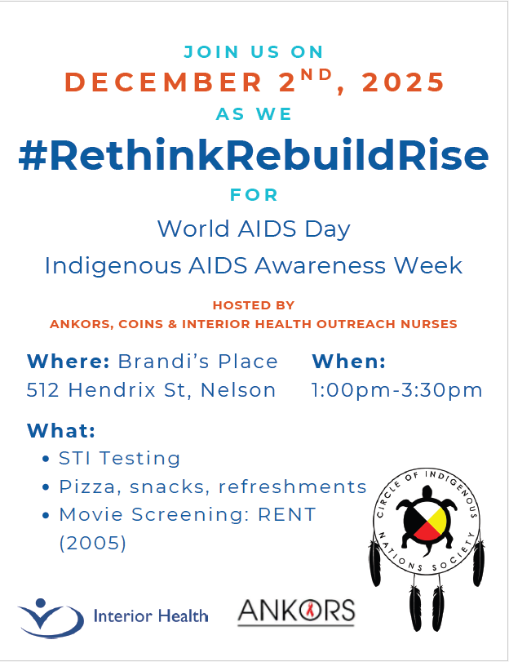
ANKORS has a special place for people who are living with HIV/AIDS. I provided grocery gift cards for each of fourteen people whose treatment was based on the HIV STOP program momentum which integrated the local HIV Nurse, local HIV doctor and ANKORS social worker (me). https://www.interiorhealth.ca/sites/default/files/2021-11/STOP%20HIV%204pager.pdf ); https://www.canada.ca/en/public-health/services/publications/diseases-conditions/canada-progress-towards-ending-hiv-epidemic.html ). I enjoy this fun annual project which was enhanced this year with the collaboration of an outreach nurse (LA) who helped deliver to some of the recipients in time for the winter holidays.
The last thing I will share in this AGM report is a note about me as I prepare to leave my ANKORS Support and Outreach social worker position. I was first led to ANKORS by my brother’s ill health in 1995, when he passed from AIDS. I volunteered my time and started part-time work on ANKORS front desk in 2012 for a few years. I took up the Support and Outreach position in 2021, and it is now time for me to retire. This decision comes with mixed feelings as I have really appreciated my time at ANKORS.
I have found the work trying at times and easily rewarding at other times. Challenges have touched me emotionally through observation of community member’s troubled and distraught lifestyles; physically through an accumulation of daily barriers, hurdles, and tragedies that our Peers endure; mentally via ever increasing digital paperwork tangles; and spiritually because active hope is the only way through to maintaining personal balance and healing. Finally I will say how much I appreciate the wisdom of the leadership and my co-workers for their ongoing support, collaboration and dedication. I feel proud to have been part of ANKORS team. I am now a better person for my time working with ANKORS. Thank-you for being my “village”.
Katia Dolan BSW (she/her/they).
I respectfully and gratefully acknowledge my relationship with the ancestral land of the unceded territories that are home to the Ktunaxa, Sinixt, and Syilx Nations. I honour all First Nations, Inuit and Métis Peoples who also dwell on this land where I live, work and play.

